Healthy lunchboxes.

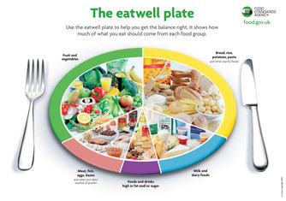
At The Manor CE Primary we know how important it is that children have a healthy, balanced lunch (based on the eatwell plate). Our school dinners, lovingly prepared by Mrs Coombs, are a very healthy choice and the best way of ensuring your child has a good balanced meal but we know some families prefer their child to have a packed lunch so we try to help you plan a fantastic lunchbox which your child will enjoy and is healthy.
Here are some good websites that give good advice on what to put in a healthy lunchbox:
http://www.nhs.uk/Change4Life/Pages/healthy-lunchbox-ideas.aspx
http://www.nhs.uk/Livewell/childhealth6-15/Pages/Lighterlunchboxes.aspx
http://www.lunchboxworld.co.uk
Also, packing a waste free lunch box could save you a LOT of money. This website is American but the ideas work on this side of the Atlantic as well:
http://www.wastefreelunches.org/what-is-a-waste-free-lunch-program.html

